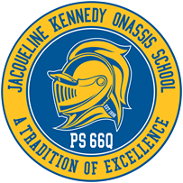
The Jacqueline Kennedy Onassis School

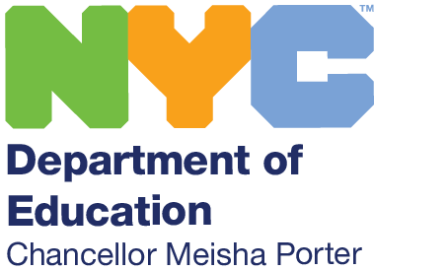
P.S. 66 Queens
“A Blue Ribbon School”

85-11 102 Street Richmond Hill, NY 11418

Telephone: (718) 558-2810

Helen DeSario, Principal

Massiel Guzman, AP (IA) Patricia Sheehan, AP

September 2021
Dear Parents,
As I begin my fifth school year as Principal of The Jacqueline Kennedy Onassis School, I am energized and deeply committed to making a positive difference in the lives of your children. An extensive amount of planning and scheduling has gone into preparing for a successful school year as we all return to full time in person learning. The past year has presented us with unimaginable challenges, but also incredible opportunities for big change. This year, healing will happen alongside rigorous academics.
Many families are excited and ready for full-time reconnection for their children. Others feel anxious, or unsure about potential risks. I can promise you that your child’s health is our number one priority, now and always. We are opening full time for every student because we know we can protect their health and safety—and yours. And we know that being in school is critically important for your child’s growth and success.
This year, we will build on what we have learned about the benefits of technology and ensure a successful transition for all of our students and families. We will provide culturally responsive supports that give students and their families’ equitable access to resources and opportunities that help students succeed inside and outside the classroom. Children are more engaged in class when they can see themselves in their lessons and materials. We are committed to reflecting the city’s “beautiful mosaic” of cultures and histories in curriculum.
I am honored to share this journey with you and your child, and look forward to reconnecting as we approach the beginning of the school year. If I can ever be of assistance, please don’t hesitate to call. Thank you for the opportunity to serve your children and I’d like to welcome each of you back to The Jacqueline Kennedy Onassis School - "Go Knights."
Warmest Regards,

Helen DeSario

