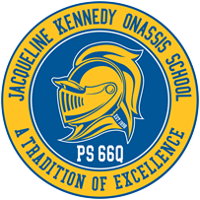
The Jacqueline Kennedy Onassis School

P.S. 66 Queens
“A Blue Ribbon School”

85-11 102 Street Richmond Hill, NY 11418

Telephone: (718) 558-2810

Helen DeSario, Principal

Massiel Guzman IA, AP Patricia Sheehan, AP

September 2021

Dear Parent/Guardian:
This letter is to remind you of the uniform policy at PS 66Q. Students should wear navy blue pants, skirt, jumper and a white top. (PS 66 apparel is also suitable.) Students are expected to wear their uniform every day.
You may purchase your uniform at any store. PS 66 polo shirts and T-shirts will be available for purchase in the main office. If you have any questions feel free to contact the school.

Sincerely,
H. DeSario, Principal

